Lesson 17: Graphs of the Other Trig Functions
Math 2412 Precalculus · Unit 3: Trigonometric Functions & Triangles · Student Guided Notes
Name: ______________________________ Date: ______________

Lesson objective
Students will graph tangent, cotangent, secant, and cosecant and their transformations, find their periods, asymptotes, domains, and ranges, and write an equation from a graph.

Before class
Complete these short tasks before the lesson. They review skills this lesson builds on.
- Where is $cos x=0$ on [−2π, 2π]? Where is $sin x=0$? (Lesson 15)
- Find the period and phase shift of $y=3sin(2x−π)$ (Lesson 16).
- Give $tan(π/4)$, $tan(−π/4)$, and explain why $tan(π/2)$ is undefined (Lesson 15).

Skill 17.1: Tangent and Cotangent

Key ideas
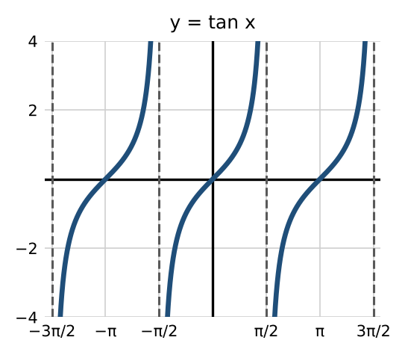 | 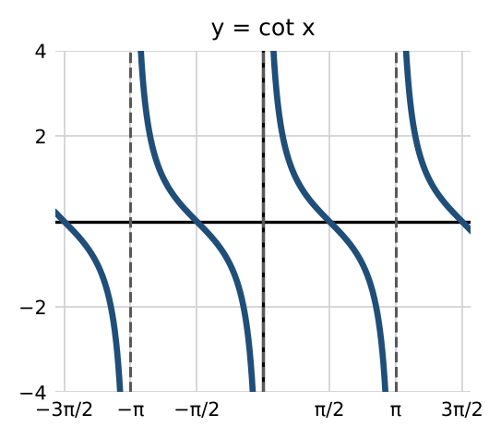

 | y = A tan(Bx − C) + D | y = A cot(Bx − C) + D
Stretching factor | $\left|A\right|$ | $\left|A\right|$
Period | ________ (1) | ________ (2)
Asymptotes (basic graph) | ________ (3), where $cos x=0$ | ________ (4), where $sin x=0$
Domain (basic graph) | all x except $π/2+kπ$ | all x except $kπ$
Range | ________ (5) | (−∞, ∞)
Shape | rises between asymptotes | ________ (6) between asymptotes

Steps: sketch one period
- Find the period $π/B$ and the phase shift $\frac{C}{B}$.
- Tangent: the asymptotes are half a period on each side of the center $x=\frac{C}{B}$. Cotangent: the asymptotes are at $x=\frac{C}{B}$ and one period later.
- Plot the center point (x, D) and the two points a quarter period away, at heights $D±A$.
- Draw the curve approaching the asymptotes.

Example 1: $y=(\frac{1}{2})tan(π\frac{x}{2})$
Period $π/(π/2)=2$; asymptotes $x=−1$ and $x=1$; points (−1/2, −1/2), (0, 0), (1/2, 1/2).
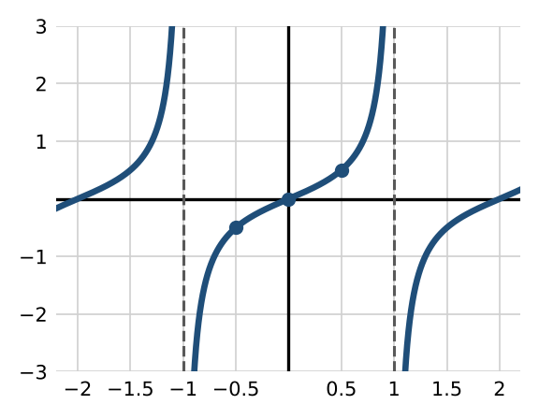

Example 2: $y=3cot(π\frac{x}{6})$
Period $π/(π/6)=6$; asymptotes $x=0$ and $x=6$; points (3/2, 3), (3, 0), (9/2, −3).
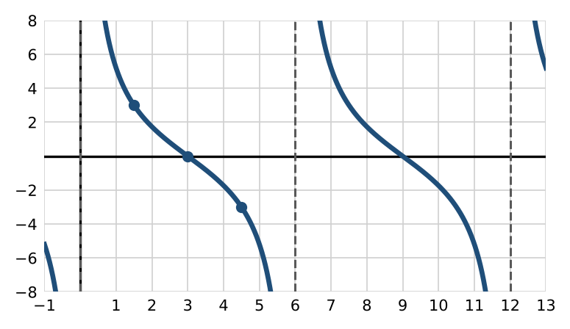

Practice
a. Sketch one period of $y=−2tan(πx+π)−1$. Give the period, the asymptotes, and three points.
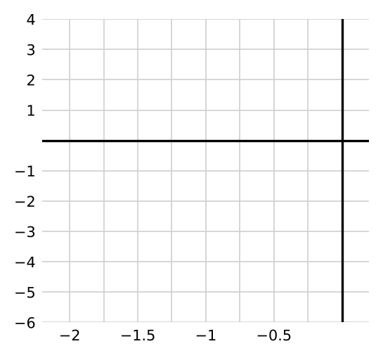

Skill 17.2: Secant and Cosecant

Key ideas
- $sec x=\frac{1}{cos x}$ and $csc x=\frac{1}{sin x}$. Sketch the cosine or sine "guide" first.
- Where the guide is 0, the reciprocal has a vertical ______________ (7). Where the guide has a maximum or minimum, the reciprocal touches it and turns back.
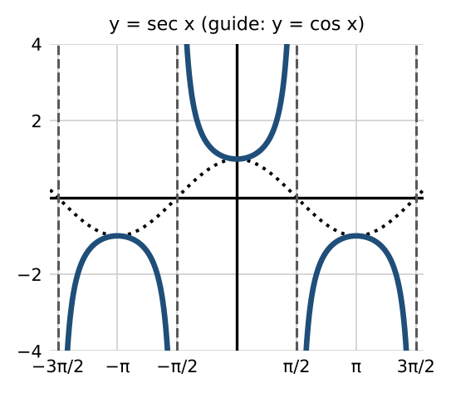 | 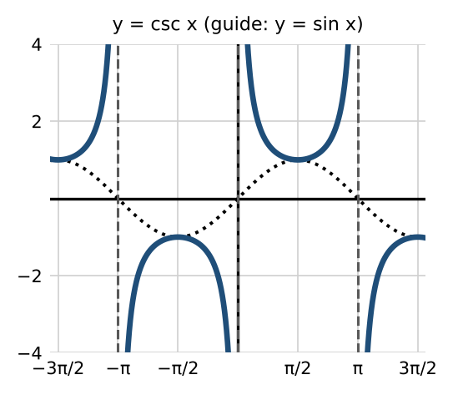

 | y = A sec(Bx − C) + D | y = A csc(Bx − C) + D
Period | ________ (8) | ________ (9)
Asymptotes (basic graph) | $x=π/2+kπ$ | $x=kπ$
Range (with $D=0$) | ________ (10) | (−∞, −|A|] ∪ [|A|, ∞)

Example 1: $y=2sec(πx)$
Guide $y=2cos(πx)$; period $2π/π=2$. Asymptotes where $cos(πx)=0$: $x=±\frac{1}{2},\frac{3}{2},…$ Turning points (0, 2) and (1, −2).
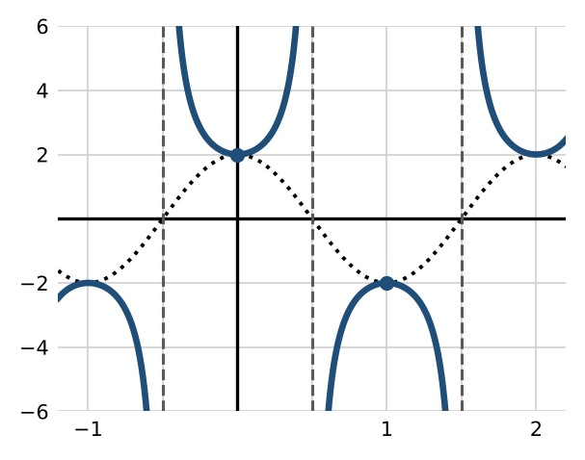

Example 2: $y=−(\frac{1}{2})csc(π\frac{x}{2})$
Guide $y=−(\frac{1}{2})sin(π\frac{x}{2})$; period 4. Asymptotes at $x=0$, 2, 4. Turning points (1, −1/2) (opens down) and (3, 1/2) (opens up).
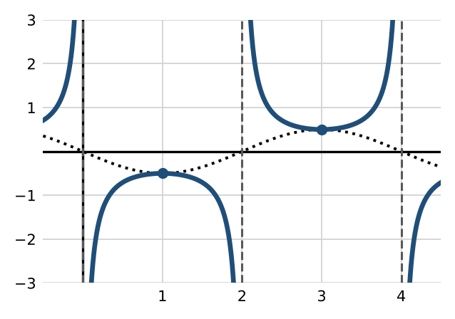

Practice
a. Sketch one period of $y=4sec(π\frac{x}{3}−π/2)+1$. Give the period, the asymptotes, and the turning points.
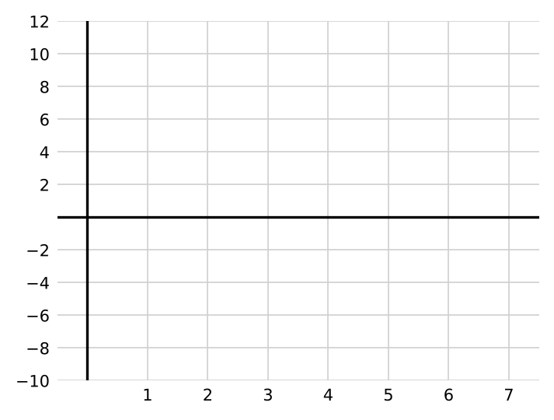
b. Find the period and range of $y=−6csc(4x+2)−8$.

Skill 17.3: Writing an Equation from a Graph

Key ideas
- Find the period from the distance between asymptotes (tangent, cotangent) or from one full cycle (secant, cosecant), then find B.
- Use a labeled point to find A.

Example
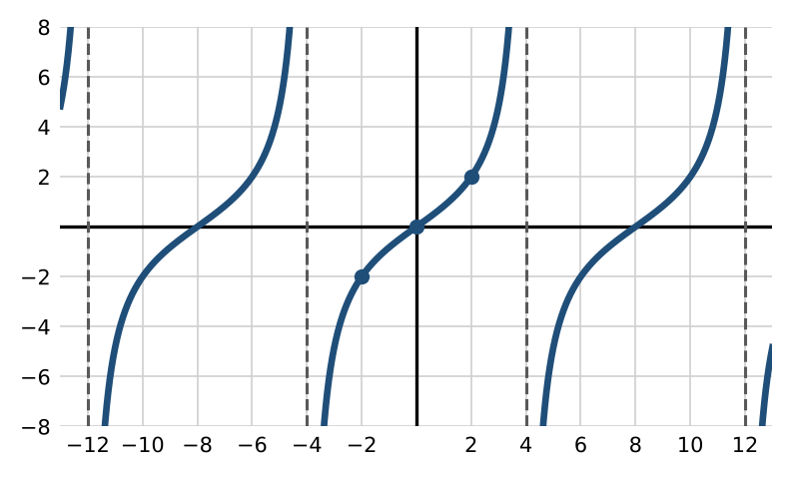
Asymptotes are 8 apart, so the period is 8 and $B=π/8$. The branch rises through (0, 0), so it is a tangent: $y=Atan(π\frac{x}{8})$. At (2, 2): $Atan(π/4)=A=2$. So $y=2tan(π\frac{x}{8})$.

Practice
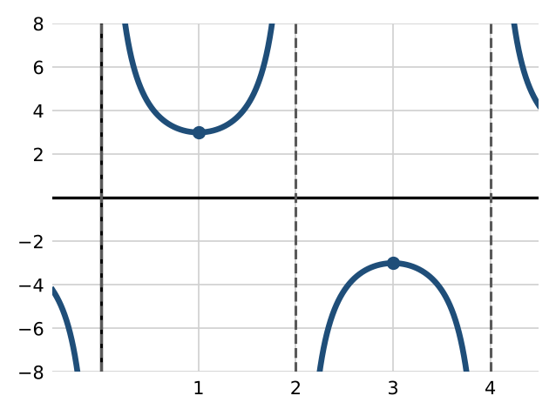
a. Write an equation for the graph above.

Exit check
1. Find the period and asymptotes of $y=tan(2x)$.

2. Find the range of $y=3sec x$.

3. Where are the asymptotes of $y=csc(x−π/4)$?

